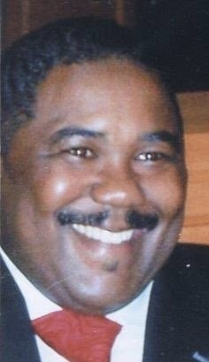

PASTOR & FOUNDER

LARRY E. REID

​

Biographical Sketch

​
But in a great house there are not only vessels of gold and of silver, but also of wood and of earth; some to honour and some to dishonor. If a man therefore purge himself from these, he shall be a vessel unto honour, sanctified and meet for the master's use and prepared unto every good work. (II Timothy 2:20-21). From his youth, Pastor Reid has set out to fulfill the aforementioned scripture by walking in obedience and in purpose. His love for God and humanity, along with a passionate pursuit of ministry, has been his life long endeavor.
​
A Servant of Jesus Christ dedicated to bringing restoration, healing, and unity to the body of Christ with a true concern for the care of souls. Pastor Reid was born on March 10, 1967, and accepted Jesus Christ as his personal savior at the age of nine and preached his first sermon at the age of thirteen. Pastor Reid attended Central State University 1991-1995 and obtained a Bachelor of Arts degree in Philosophy and Religion. Additional graduate courses were completed after 1995.
​
Continuing to be involved in active ministry throughout his years in college upon graduating, Pastor Reid served as the Executive Secretary and Chairman of the district of churches (Church of God in Christ in both Ohio and Georgia respectively). At the age of 27, Pastor Reid founded the Mason Memorial Church of God in Christ and the Bread of Life radio broadcast.
​
At hearing the voice of God commissioning him to further the scope of his ministry, in 1996 Pastor Reid joined the ministerial staff of Greater Community Church of God in Christ in the Atlanta metropolitan area, where he served for several years until God spoke to his heart about planting a new ministry. By the Grace of God and with the same fervent fear unto Him, Pastor Reid established Redemptive Life Fellowship Community Church in a living room with 4 people. From the living room to its first church building. To God be the Glory. In 2013, Pastor Reid served as Interim Pastor of Trinity Fellowship Church of God in Christ in Riverside, California.
​
Pastor Reid has now been preaching the Word of God for more than four decades, in addition to touching lives through his outreach ministry, Larry E. Reid Ministries Inc. dba Community Impact Center, which is a 501 copyrighted Charitable Organization designed to impact the community and bring restoration, healing and wholeness to all people. His secular and professional work is extensive in corporate America and in the area of education: Small Business Telesales Representative and Residential Telesales Supervisor MCI WorldCom, Customer Marketing Sales Specialist MBNA, Licensed Insurance Agent Premier Financial Group/Get Insured, a former Licensed Behavior Therapist with People’s Care and an Educator for the Riverside, California Unified and Kettering, Ohio School Districts, respectively.
​
Pastor Reid is a very warm, loving and caring man who truly loves humanity and has a shepherd's heart. He has been blessed to travel and minister at various ministries throughout the nation. In 2017, Pastor Reid founded Restoration of Hope Community Church of God in Christ in Dayton, Ohio where he currently serves as Senior Pastor. He along with his congregation are members of the Ohio North First Ecclesiastical Jurisdiction Church of God in Christ where Bishop Edward T. Cook is the Prelate.

